**OADG109Aキーボード**  
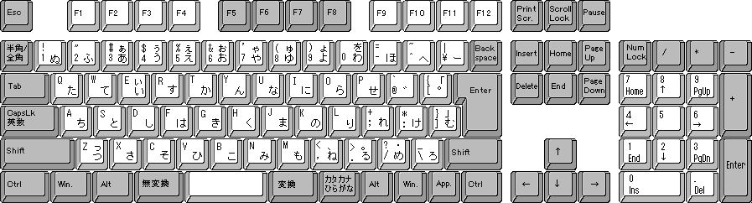  
  
キー番号図  
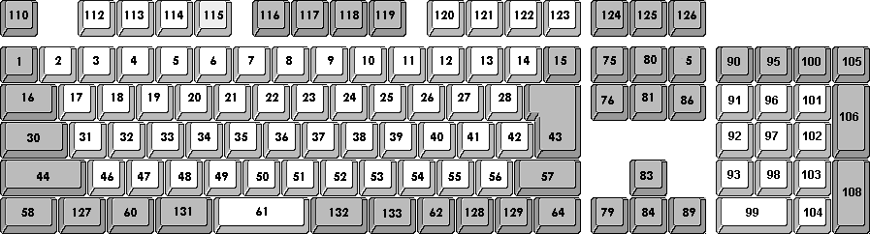  
※OADG テクニカル・リファレンス ハードウェア偏には、127～129 のキー番号は使われていませんが、HID Usage Tables Version 1.11 で使われていましたので採用いたしました。

|  |  |  |  |  |
| --- | --- | --- | --- | --- |
| **キー番号** | **OADG109Aキーボード** | **Apple Pro キーボード (JIS配列)** | **Usage Name (HID Usage Tables 1.11)** | **USB キーコード (hex) Usage Page / Usage ID** |
| 1 | 半角/全角 | ----- | Keyboard Grave Accent and Tilde | 07 / 35 |
| 2 | 1 ! | 1 ! | Keyboard 1 and ! | 07 / 1E |
| 3 | 2 " | 2 " | Keyboard 2 and @ | 07 / 1F |
| 4 | 3 # | 3 # | Keyboard 3 and # | 07 / 20 |
| 5 | 4 $ | 4 $ | Keyboard 4 and $ | 07 / 21 |
| 6 | 5 % | 5 % | Keyboard 5 and % | 07 / 22 |
| 7 | 6 & | 6 & | Keyboard 6 and ^ | 07 / 23 |
| 8 | 7 ' | 7 ' | Keyboard 7 and & | 07 / 24 |
| 9 | 8 ( | 8 ( | Keyboard 8 and * | 07 / 25 |
| 10 | 9 ) | 9 ) | Keyboard 9 and ( | 07 / 26 |
| 11 | 0 | 0 | Keyboard 0 and ) | 07 / 27 |
| 12 | - = | - = | Keyboard - and (underscore) | 07 / 2D |
| 13 | ^ ~ | ^ ~ | Keyboard = and + | 07 / 2E |
| 14 | ￥ ｜ | ￥ ｜ | Keyboard International3 | 07 / 89 |
| 15 | Backspace | Delete | Keyboard DELETE (Backspace) | 07 / 2A |
| 16 | Tab | Tab | Keyboard Tab | 07 / 2B |
| 17 | Q | Q | Keyboard q and Q | 07 / 14 |
| 18 | W | W | Keyboard w and W | 07 / 1A |
| 19 | E | E | Keyboard e and E | 07 / 08 |
| 20 | R | R | Keyboard r and R | 07 / 15 |
| 21 | T | T | Keyboard t and T | 07 / 17 |
| 22 | Y | Y | Keyboard y and Y | 07 / 1C |
| 23 | U | U | Keyboard u and U | 07 / 18 |
| 24 | I | I | Keyboard i and I | 07 / 0C |
| 25 | O | O | Keyboard o and O | 07 / 12 |
| 26 | P | P | Keyboard p and P | 07 / 13 |
| 27 | @ ` | @ ` | Keyboard [ and { | 07 / 2F |
| 28 | [ { | [ { | Keyboard ] and } | 07 / 30 |
| 29 | ----- | ----- | Keyboard ＼ and | | 07 / 31 |
| 30 | 英数 Caps Lock | Caps Lock | Keyboard Caps Lock | 07 / 39 |
| 31 | A | A | Keyboard a and A | 07 / 04 |
| 32 | S | S | Keyboard s and S | 07 / 16 |
| 33 | D | D | Keyboard d and D | 07 / 07 |
| 34 | F | F | Keyboard f and F | 07 / 09 |
| 35 | G | G | Keyboard g and G | 07 / 0A |
| 36 | H | H | Keyboard h and H | 07 / 0B |
| 37 | J | J | Keyboard j and J | 07 / 0D |
| 38 | K | K | Keyboard k and K | 07 / 0E |
| 39 | L | L | Keyboard l and L | 07 / 0F |
| 40 | ; + | ; + | Keyboard ; and : | 07 / 33 |
| 41 | : * | : * | Keyboard ‘ and “ | 07 / 34 |
| 42 | ] } | ] } | Keyboard Non-US # and ~ | 07 / 32 |
| 43 | Enter | Return | Keyboard Return (ENTER) | 07 / 28 |
| 44 | Left Shift | Left Shift | Keyboard LeftShift | 07 / E1 |
| 46 | Z | Z | Keyboard z and Z | 07 / 1D |
| 47 | X | X | Keyboard x and X | 07 / 1B |
| 48 | C | C | Keyboard c and C | 07 / 06 |
| 49 | V | V | Keyboard v and V | 07 / 19 |
| 50 | B | B | Keyboard b and B | 07 / 05 |
| 51 | N | N | Keyboard n and N | 07 / 11 |
| 52 | M | M | Keyboard m and M | 07 / 10 |
| 53 | , < | , < | Keyboard, and < | 07 / 36 |
| 54 | . > | . > | Keyboard . and > | 07 / 37 |
| 55 | / ? | / ? | Keyboard / and ? | 07 / 38 |
| 56 | ＼ _ | _ | Keyboard International1 | 07 / 87 |
| 57 | Right Shift | Right Shift | Keyboard RightShift | 07 / E5 |
| 58 | Left Ctrl | Left Control | Keyboard LeftControl | 07 / E0 |
| 60 | Left Alt | Left Option | Keyboard LeftAlt | 07 / E2 |
| 61 | Spacebar | Spacebar | Keyboard Spacebar | 07 / 2C |
| 62 | Right Alt | Right Option | Keyboard RightAlt | 07 / E6 |
| 64 | Right Ctrl | Right Control | Keyboard RightControl | 07 / E4 |
| 75 | Insert | Help | Keyboard Insert | 07 / 49 |
| 76 | Delete | Delete Forward | Keyboard Delete Forward | 07 / 4C |
| 79 | ← | ← | Keyboard LeftArrow | 07 / 50 |
| 80 | Home | Home | Keyboard Home | 07 / 4A |
| 81 | End | End | Keyboard End | 07 / 4D |
| 83 | ↑ | ↑ | Keyboard UpArrow | 07 / 52 |
| 84 | ↓ | ↓ | Keyboard DownArrow | 07 / 51 |
| 85 | Page Up | Page Up | Keyboard PageUp | 07 / 4B |
| 86 | Page Down | Page Down | Keyboard PageDown | 07 / 4E |
| 89 | → | → | Keyboard RightArrow | 07 / 4F |
| 90 | Num Lock | Clear | Keypad Num Lock and Clear | 07 / 53 |
| 91 | Keypad 7 | Keypad 7 | Keypad 7 and Home | 07 / 5F |
| 92 | Keypad 4 | Keypad 4 | Keypad 4 and Left Arrow | 07 / 5C |
| 93 | Keypad 1 | Keypad 1 | Keypad 1 and End | 07 / 59 |
| 95 | Keypad / | Keypad / | Keypad / | 07 / 54 |
| 96 | Keypad 8 | Keypad 8 | Keypad 8 and Up Arrow | 07 / 60 |
| 97 | Keypad 5 | Keypad 5 | Keypad 5 | 07 / 5D |
| 98 | Keypad 2 | Keypad 2 | Keypad 2 and Down Arrow | 07 / 5A |
| 99 | Keypad 0 | Keypad 0 | Keypad 0 and Insert | 07 / 62 |
| 100 | Keypad * | Keypad * | Keypad * | 07 / 55 |
| 101 | Keypad 9 | Keypad 9 | Keypad 9 and PageUp | 07 / 61 |
| 102 | Keypad 6 | Keypad 6 | Keypad 6 and Right Arrow | 07 / 5E |
| 103 | Keypad 3 | Keypad 3 | Keypad 3 and PageDn | 07 / 5B |
| 104 | Keypad . | Keypad . | Keypad . and Delete | 07 / 63 |
| 105 | Keypad - | Keypad - | Keypad - | 07 / 56 |
| 106 | Keypad + | Keypad + | Keypad + | 07 / 57 |
| 108 | Keypad Enter | Keypad Enter | Keypad ENTER | 07 / 58 |
| 110 | Esc | Esc | Keyboard ESCAPE | 07 / 29 |
| 112 | F1 | F1 | Keyboard F1 | 07 / 3A |
| 113 | F2 | F2 | Keyboard F2 | 07 / 3B |
| 114 | F3 | F3 | Keyboard F3 | 07 / 3C |
| 115 | F4 | F4 | Keyboard F4 | 07 / 3D |
| 116 | F5 | F5 | Keyboard F5 | 07 / 3E |
| 117 | F6 | F6 | Keyboard F6 | 07 / 3F |
| 118 | F7 | F7 | Keyboard F7 | 07 / 40 |
| 119 | F8 | F8 | Keyboard F8 | 07 / 41 |
| 120 | F9 | F9 | Keyboard F9 | 07 / 42 |
| 121 | F10 | F10 | Keyboard F10 | 07 / 43 |
| 122 | F11 | F11 | Keyboard F11 | 07 / 44 |
| 123 | F12 | F12 | Keyboard F12 | 07 / 45 |
| 124 | Print Screen | ----- | Keyboard PrintScreen | 07 / 46 |
| 125 | Scroll Lock | ----- | Keyboard Scroll Lock | 07 / 47 |
| 126 | Pause | ----- | Keyboard Pause | 07 / 48 |
| 127 | Left Windows | Left Command | Keyboard Left GUI | 07 / E3 |
| 128 | Right Windows | Right Command | Keyboard Right GUI | 07 / E7 |
| 129 | Application | ----- | Keyboard Application | 07 / 65 |
| 131 | 無変換 | ----- | Keyboard International5 | 07 / 8B |
| 132 | 変換 | ----- | Keyboard International4 | 07 / 8A |
| 133 | ひらがな カタカナ | ----- | Keyboard International2 | 07 / 88 |
|  |  |  |  |  |
| 300 | ----- | F13 | Keyboard F13 | 07 / 68 |
| 301 | ----- | F14 | Keyboard F14 | 07 / 69 |
| 302 | ----- | F15 | Keyboard F15 | 07 / 6A |
| 303 | ----- | Keypad = | Keypad = | 07 / 67 |
| 304 | ----- | Keypad , (Comma) | Keypad Comma | 07 / 85 |
| 305 | ----- | 英数 | Keyboard LANG2 | 07 / 91 |
| 306 | ----- | かな カナ | Keyboard LANG1 | 07 / 90 |
|  |  |  |  |  |
| 400 | ----- | Volume Decrement | Volume Decrement | 0C / 00EA |
| 401 | ----- | Volume Increment | Volume Increment | 0C / 00E9 |
| 402 | ----- | Mute | Mute | 0C / 00E2 |
| 403 | ----- | Eject | Eject | 0C / 00B8 |